DRAFT

To: Audit & Governance Committee

Date: 26th February 2015

Report of: Head of Finance

Title of Report: Risk Management Quarterly Reporting: Quarter 3 2014/2015

Summary and Recommendations

Purpose of report: To update the Committee on both corporate and service risks as at the end of Quarter 3, 31st December 2014.

Key decision: No

Executive lead member: Councillor Ed Turner

Policy Framework: Corporate Plan - Efficient, Effective Council

Recommendation(s): The Committee are asked to note the contents of this report.

Appendix A Corporate Risk Register

Business Continuity Planning (BCP)

- Following recent events in Paris, associated threats to a business in Broad Street and the recent fire at the offices of South Oxfordshire District Council, a high level review of emergency and business Continuity Plans has taken place. The Risk Group has been commissioned to review the Business Impact Assessments (BIA) of Service’s Business Continuity Plans.

- Business Impact Assessments identify and document the key functions of a service area; the critical activities required to deliver them; the impact that a disruption of the activities would have on the Council; and the resources required to resume the activities. Reviews will inform any changes required to Service’s Business Continuity Plans.

- Table top test scenario’s will also take place, to capture all service areas by the end of April 2015.

- Whilst the Risk Group does not have any concerns over the current plans that are in place, it is considered a timely reminder to ensure that they up to date and fit for purpose.

On-line Training module

- A new on-line training module will be released to staff and members by the end of March 2015. The module covers the basic principles of Risk Management and seeks to raise the profile of the subject within the Council.

Risk Scoring Matrix

- The Council’s methodology for scoring risks is set out below along with a copy of the scoring matrix.

- It is possible to get the same score but end up with a different result in the heat map. For example if the probability of an event occurring is high but the impact is low it is likely to have a lower score on the heat map. However, the higher the potential impact score the more likely the event will be classed as a red risk on the matrix.
 | Probability
 | Almost Certain | 5 | 5 | 10 | 15 | 20 | 25
 | Likely | 4 | 4 | 8 | 12 | 16 | 20
 | Possible | 3 | 3 | 6 | 9 | 12 | 15
 | Unlikely | 2 | 2 | 4 | 6 | 8 | 10
 | Rare | 1 | 1 | 2 | 3 | 4 | 5
 |  |  | 1 | 2 | 3 | 4 | 5
 |  | Impact | Negligible | Low | Medium | High | Very High

Green | Amber | Red
Key:

Risk Identification

- Corporate Risks – The Corporate Risk Register (CRR) is reviewed by the Corporate Management Team (CMT) on a quarterly basis, any new risks are incorporated into a revised version of the CRR. Risk owners for corporate risks are generally held at Director level.

- Service Risks – Service area risks are reviewed periodically by Heads of Service and Service Managers. The Financial Accounting Manager has oversight of all risks and on a quarterly basis will review service risks to determine the need for inclusion in the Corporate Risk Register.

- Project and Programme Risk – The Council adopts the principles of Prince2 methodology for managing projects. Incorporated within this methodology is a robust process for the management of risk within a project environment. Each project is managed by the Project Manager who controls and co-ordinates all aspects of the project through to conclusion.

Quarter 3 Corporate Risk Register

- The current Corporate Risk Register (Appendix A) shows that there are no red risks and the number of red risks have remained at zero same since Q4 2014. The table below shows the movement of risks over the last 15 months.

Current Risk | Q3  2013/14 | Q4  2013/14 | Q1  2014/15 | Q2 2014/15 | Q3 2014/15
Red | 0 | 0 | 0 | 0 | 0
Amber | 9 | 5 | 5 | 5 | 6
Green | 2 | 6 | 6 | 6 | 5
Total risks | 11 | 11 | 11 | 11 | 11

Corporate Risk Summary

- The table below shows the how the corporate risks have been scored in accordance to the risk matrix.
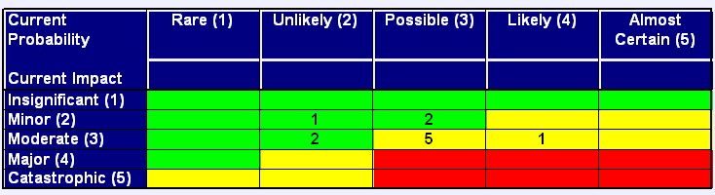

Quarter 3 Service Risk Register

- The table below shows the number of current risks for Q3 2014/15 compared with the last 15 months. Four risks have been closed since the last quarter.

Current Risk | Q3  2013/14 | Q4  2013/14 | Q1 2014/15 | Q2 2014/15 | Q3 2014/15
Red | 2 | 0 | 3 | 0 | 0
Amber | 48 | 38 | 36 | 41 | 38
Green | 36 | 46 | 42 | 36 | 39
Total risks | 86 | 84 | 81 | 81 | 77
New risks in quarter | 0 | 0 | 0 | 3 | 0
Closed | 3 | 2 | 3 | 3 | 4

Service Area Risk Summary

- The table below shows the how the service area risks have been scored in accordance to the risk matrix.

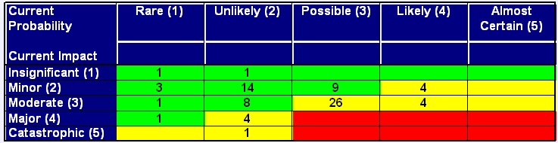

All risks continued to be mitigated and the number of red risks remains consistent with Q2. The risks will however be reviewed as part of service planning and will take in to account their BIA’s.

Legal Issues

- There are no legal implications directly relevant to this report but having proper arrangements to manage risk throughout the organisation is an important component of corporate governance.

Financial Issues

- The Robust management of risk should assist in mitigating the financial impact to the Council should the event occur.

Environmental Impact

- This report contains no environmental impact.

Level of Risk:

- See appendix A

Equalities:

- This report does not contain any potential equalities impact issues.

Name and contact details of author:-
Name: Shaun Vinnicombe
Job title : Risk and Insurance Officer
Service Area / Department : Finance
Tel: 01865 252048 e-mail: svinnicombe@oxford.gov.uk

